Financial Screen Tips:
Questions to ask yourself:
- When did the payment reject?
- What is the reason the payment rejected?
- Is the payment a full direct debit or an odd amount? Why?
- Has the member had a suspension in place / credit on the account?

When did the payment reject?
The payment timeline is the most accurate way to view WHEN the payment bounced. Outstanding payments will appear in red on the timeline, however this amount does not always show an accurate outstanding balance. When you click on the red payment, it will give a breakdown of the payment.
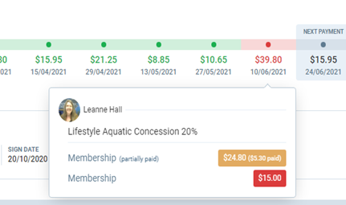
With the example above, we would think the outstanding amount would be $39.80, however when we click on the breakdown of the payment, it shows that this member’s normal membership payment is $24.80 and they have had $5.30 of this amount already paid. This results in a DD amount of $19.50 (the difference). This payment declined and has incurred the $15 admin fee, resulting in an outstanding balance of $34.50.
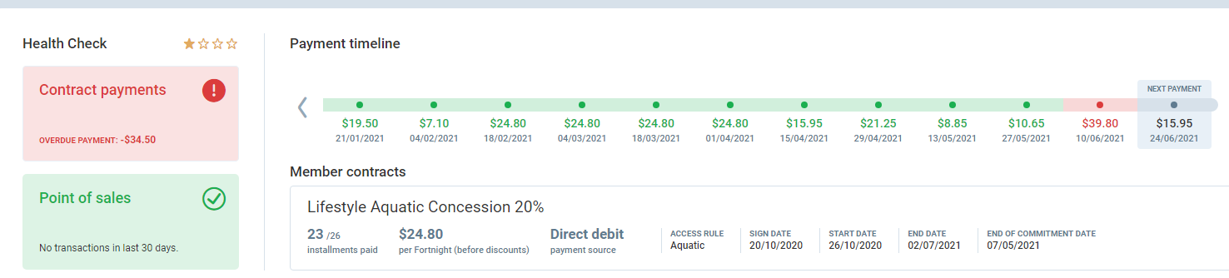
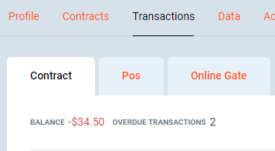
The most accurate way to view exactly HOW MUCH is outstanding on an account is on the left hand side of the timeline (contract payments circled above) or at the top of the transactions screen.

What is the reason the payment rejected?
The best way to view WHY a payment has rejected is under the notes section of the members PGM account.
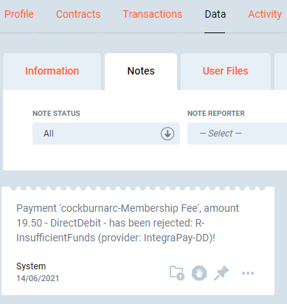
This particular member has rejected due to insufficient funds.
Common reasons that payments may bounce include:
- Insufficient funds
- Invalid credit card
- Expired credit card
- Transaction declined
- Authority revoked by payer
- Stolen / Pick up credit card
- Invalid Account BSB
- Invalid Bank Account number
- Not processed (payer inactive)
  - Payer inactive – you will need to look further back at older notes to see the original rejection reason. See eg: Max Beavis #38872

Admin fee? Why?
The $15 administration fee is a cost that is dictated by the reason of rejection from the bank. It is an automatic charge that is added to the account to cover the fee we incur from the bank, and administration time to follow up with outstanding accounts.

Is the outstanding balance a full direct debit or an odd amount? What do I do?
- Refer to the transaction page
- Under debit it will show the amount.
- If it is a full payment owing, view under the notes section as listed above and advise the customer of why the payment has rejected.
- If it is an odd amount we need to do more digging.
  - Most of the time this is due to a previous suspension that has left credit on the account, reducing the amount owing
OR:
  - An upcoming suspension and the member has not suspended for the full 14 days, the odd amount will be a pro-rata amount for the days the member was not suspended
OR:
  - Member has early returned and the outstanding balance is the pro-rata amount to pay for the days in the fortnight that their membership is now active
- Refer to their previous suspensions and DD calendar to see if they suspended mid-way through a debit, this will result in a suspension credit being applied and a reduced amount outstanding.
- Clicking on the (i) next to the debit will give a break-down of the payment we have received and if it has come from suspension credit or been settled on a different date.
(see e.g below)

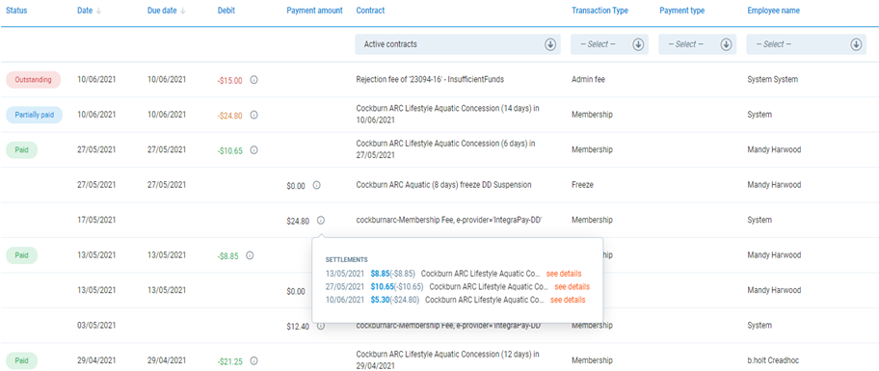

As we can see from above for the member Leanne Hall #23094 – we received a payment of $24.80 on the 17/05/2021, this member then suspended their membership (see Freezes) and the suspension cred has been divided up to cover the debit on the 27/05/2021 and part of the 10/06/2021.

Partially paid? How do I understand this?
The blue partially paid Status in the financial screen indicates the charge was not a full direct debit, and that it has been partially paid by a previous debit due to a suspension.

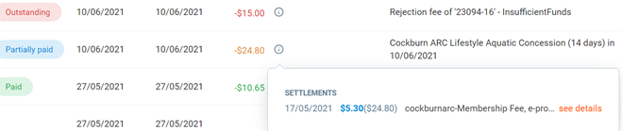

As per the example above if we click on the (i) for the $24.80 partially paid transaction, we can see $5.30 out of the normal ($24.80) has been covered by the direct debit on the 17/05/2021.

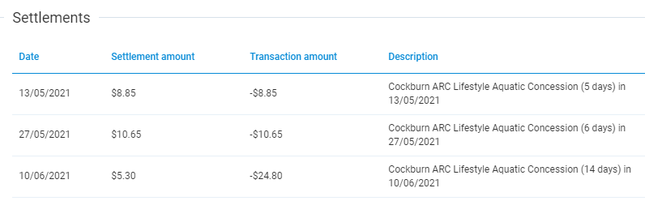
If we click see details we can see further information from where the payment on the 17/05/2021 has been allocated. See below:

We can see on the 10/06/2021 we should have received $24.80, however we only received the $5.30 (credit), this member would have had an attempted direct debit of $19.50 on the 10/06/2021.

Can you see why it rejected?

** Handy Tip: If you don’t understand the breakdown in PGM at all, log into the members portal under payments. This, along with POS will show you clearly the correct amount owed **
