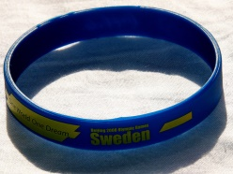
Aquatic Member Entry Register
By signing below, I acknowledge the terms and conditions of my membership agreement; in particular that I must provide notice to Cockburn ARC should my membership access be missing or stolen. In the event that the Centre suspects misuse of my membership access under clause 2.3.5, they reserve the right to investigate. Should I breach this term, I understand I will be fined under clause 2.3.5 of the membership terms and conditions.
Date | Time of Entry | Member Name | Member Number | Member Signature | Entered through POS to record visit | CSO Check Initial
Aquatic Member Entry Register
By signing below, I acknowledge the terms and conditions of my membership agreement; in particular that I must provide notice to Cockburn ARC should my membership access be missing or stolen. In the event that the Centre suspects misuse of my membership access under clause 2.3.5, they reserve the right to investigate. Should I breach this term, I understand I will be fined under clause 2.3.5 of the membership terms and conditions.
Date | Time of Entry | Member Name | Member Number | Member Signature | Entered through POS to record visit | CSO Check Initial

