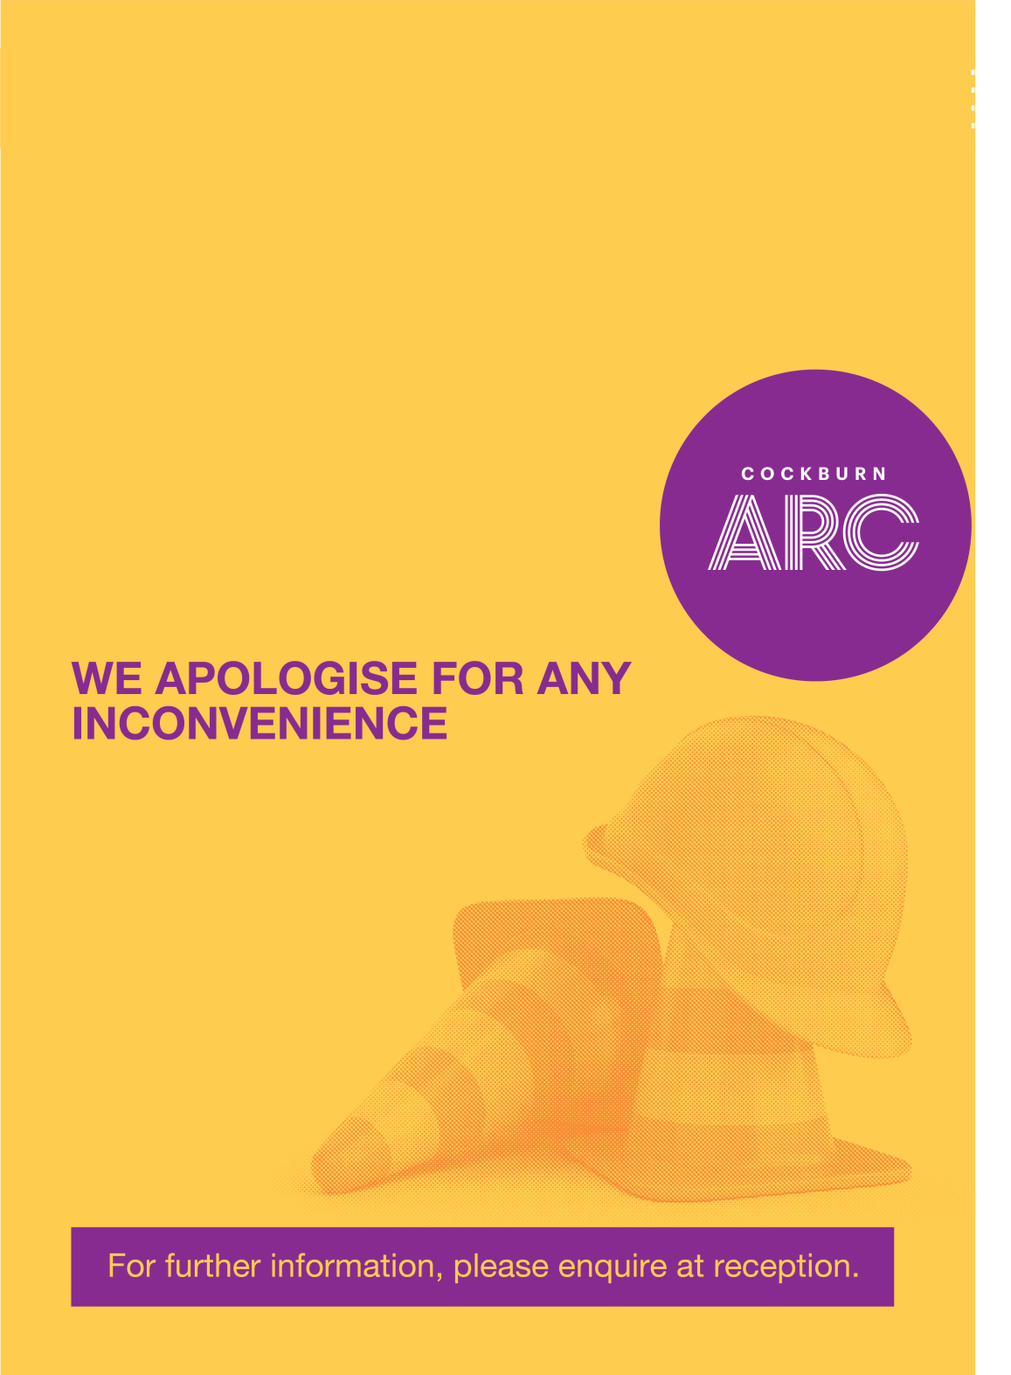

**NAME THE AREA THAT IS UNAVAILABLE**

**TIME OR ADDITIONAL**

**INFO**